**COMPUTER VISION**

**CODE 1**:

import cv2  
  
# For USB webcam (index 0 = first camera)  
cap = cv2.VideoCapture(0)  
  
# For IP camera (replace with your IP stream URL)  
# cap = cv2.VideoCapture("rtsp://username:password@ip:554/stream")  
  
while True:  
    ret, frame = cap.read()  
    if not ret:  
        break  
  
    cv2.imshow("Camera Stream", frame)  
  
    if cv2.waitKey(1) & 0xFF == ord("q"):  
        break  
  
cap.release()  
cv2.destroyAllWindows()

**OUTPUT:** Live stream

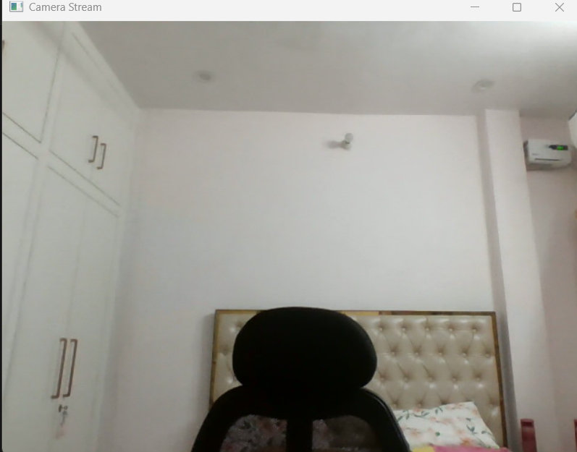

**OBSERVATIONS:**

1 The program turns on a camera

2 It keeps taking pictures from the camera continuously

3 Each picture is shown on your screen in a window

4 You can stop the program by pressing a key like q

5 After stopping it closes the camera and the window properly

_________________________________________________________________________________

**CODE 2**

import cv2

import os

cap = cv2.VideoCapture(0)

# Create output folder

os.makedirs("frames", exist_ok=True)

frame_count = 0

while True:

ret, frame = cap.read()

if not ret:

break

# Show stream

cv2.imshow("Camera Stream", frame)

# Save frame

filename = f"frames/frame_{frame_count:06d}.jpg"

cv2.imwrite(filename, frame)

frame_count += 1

if cv2.waitKey(1) & 0xFF == ord("q"):

break

cap.release()

cv2.destroyAllWindows()

**OUTPUT:** Live camera feed + saved frames

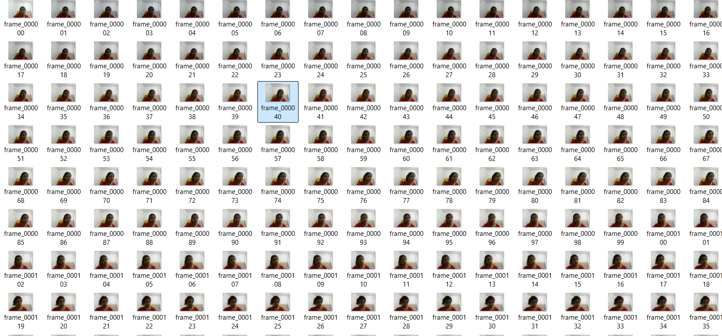  
**OBSERVATIONS:**  
1 The program turns on a camera  
2 It captures frames continuously from the camera  
3 Each frame is shown on screen  
4 Each frame is saved in a folder named frames  
5 You can stop the program by pressing a key like q  
6 After stopping it releases the camera and closes windows

**CODE 3**

from PIL import Image

import cv2

import numpy as np

# Open AVIF image using Pillow

pil_img = Image.open("C://Users//HP-PC//OneDrive//Documents//apple.avif")

# Convert to OpenCV format

img = cv2.cvtColor(np.array(pil_img), cv2.COLOR_RGB2BGR)

cv2.imshow("My Image", img)

cv2.waitKey(0)

cv2.destroyAllWindows()

**OUTPUT:** Display a single image

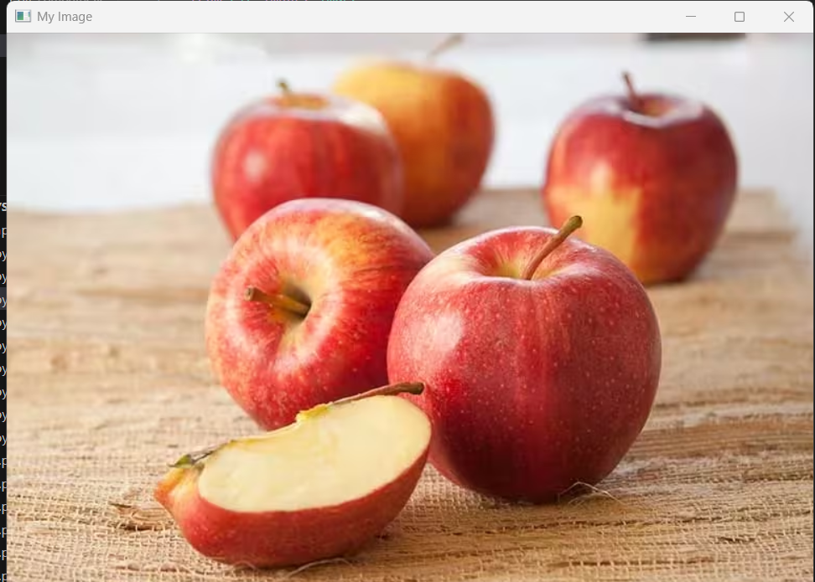  
**OBSERVATIONS:**  
1 The program loads an image from disk  
2 It checks if the image exists  
3 Shows the image in a window  
4 Waits until a key is pressed to close  
5 Closes the window after key press

**CODE 4**

from PIL import Image

import pillow_avif  # make sure you installed pillow-avif-plugin

import cv2

import numpy as np

# Load AVIF image using Pillow

pil_img = Image.open(r"C:\Users\HP-PC\OneDrive\Documents\apple.avif")

# Convert to OpenCV format

img = cv2.cvtColor(np.array(pil_img), cv2.COLOR_RGB2BGR)

if img is None:

    print("Error: Could not read image.")

else:

    # Flip vertically (0), horizontally (1), or both (-1)

    flip_vertical = cv2.flip(img, 0)

    flip_horizontal = cv2.flip(img, 1)

    flip_both = cv2.flip(img, -1)

    # Show results

    cv2.imshow("Original", img)

    cv2.imshow("Flipped Vertically", flip_vertical)

    cv2.imshow("Flipped Horizontally", flip_horizontal)

    cv2.imshow("Flipped Both", flip_both)

    cv2.waitKey(0)

    cv2.destroyAllWindows()

**OUTPUT:** Original and flipped images

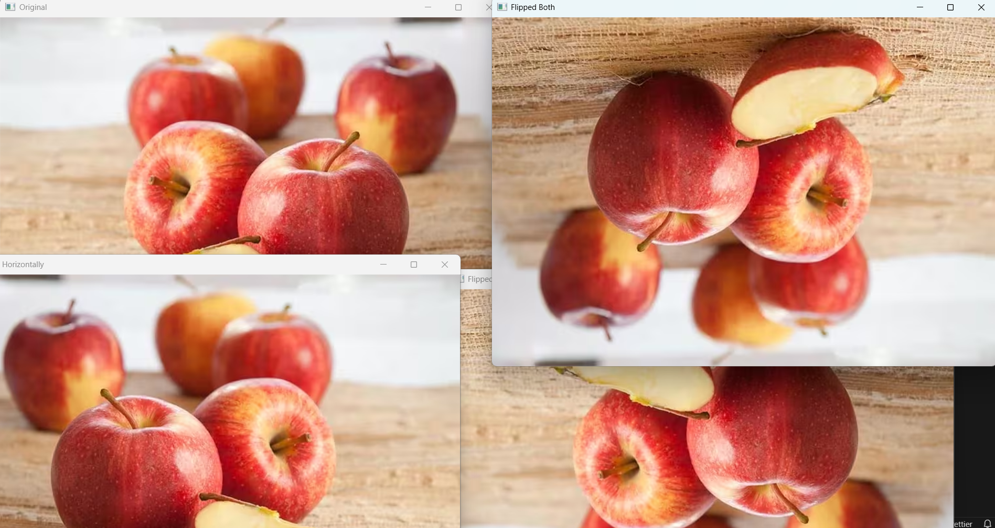  
**OBSERVATIONS:**  
1 The program loads an image  
2 It creates vertical, horizontal, and both-direction flips  
3 Shows original and flipped images  
4 Waits for a key press to close  
5 Closes all windows after key press

**CODE 5**

from PIL import Image

import pillow_avif  # make sure pillow-avif-plugin is installed

import cv2

import numpy as np

# Load AVIF image using Pillow

pil_img = Image.open(r"C:\Users\HP-PC\OneDrive\Documents\apple.avif")

# Convert to OpenCV format

img = cv2.cvtColor(np.array(pil_img), cv2.COLOR_RGB2BGR)

# Check if the image loaded correctly

if img is None:

    print("Error: Could not read image.")

    exit()

# Resize image (width=300, height=300)

resized = cv2.resize(img, (300, 300))

# Show both

cv2.imshow("Original", img)

cv2.imshow("Resized", resized)

# Wait for a key press

cv2.waitKey(0)

cv2.destroyAllWindows()

# Optional: Save the resized image

cv2.imwrite("resized_output.jpg", resized)

**OUTPUT:** Original and resized images

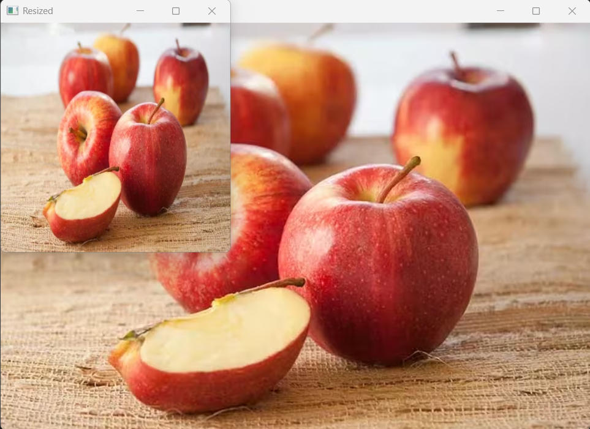  
**OBSERVATIONS:**  
1 Loads an image from disk  
2 Checks if image loaded correctly  
3 Resizes the image to 300x300 pixels  
4 Shows original and resized images  
5 Saves the resized image to disk  
6 Closes windows after key press

**CODE 6**

from PIL import Image

import pillow_avif  # make sure pillow-avif-plugin is installed

import cv2

import numpy as np

# Load AVIF image using Pillow

pil_img = Image.open(r"C:\Users\HP-PC\OneDrive\Documents\apple.avif")

# Convert to OpenCV format

img = cv2.cvtColor(np.array(pil_img), cv2.COLOR_RGB2BGR)

# Check if image loaded correctly

if img is None:

    print("Error: Could not read image.")

    exit()

# Convert to grayscale

gray = cv2.cvtColor(img, cv2.COLOR_BGR2GRAY)

# Show both

cv2.imshow("Original", img)

cv2.imshow("Grayscale", gray)

# Wait until a key is pressed

cv2.waitKey(0)

cv2.destroyAllWindows()

# Optional: Save grayscale image

cv2.imwrite("grayscale_output.jpg", gray)

**OUTPUT:** grayscale images

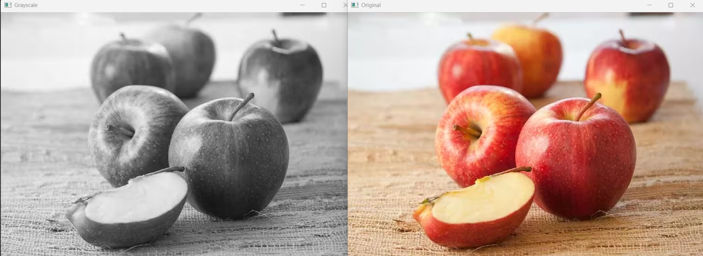  
**OBSERVATIONS:**  
1 Loads an image from disk  
2 Converts the image to grayscale  
3 Shows original and grayscale images  
4 Optionally saves the grayscale image  
5 Waits for a key press then closes all windows

**CODE 7**

from PIL import Image

import pillow_avif  # make sure pillow-avif-plugin is installed

import cv2

import numpy as np

# Load AVIF image using Pillow

pil_img = Image.open(r"C:\Users\HP-PC\OneDrive\Documents\apple.avif")

# Convert to OpenCV format

img = cv2.cvtColor(np.array(pil_img), cv2.COLOR_RGB2BGR)

# Check if image loaded correctly

if img is None:

    print("Error: Could not read image.")

    exit()

# Apply Gaussian Blur (15x15 kernel)

blur = cv2.GaussianBlur(img, (15, 15), 0)

# Show both

cv2.imshow("Original", img)

cv2.imshow("Blurred", blur)

# Wait for key press

cv2.waitKey(0)

cv2.destroyAllWindows()

# Optional: Save the blurred image

cv2.imwrite("blurred_output.jpg", blur)

**OUTPUT:** Original and blurred images

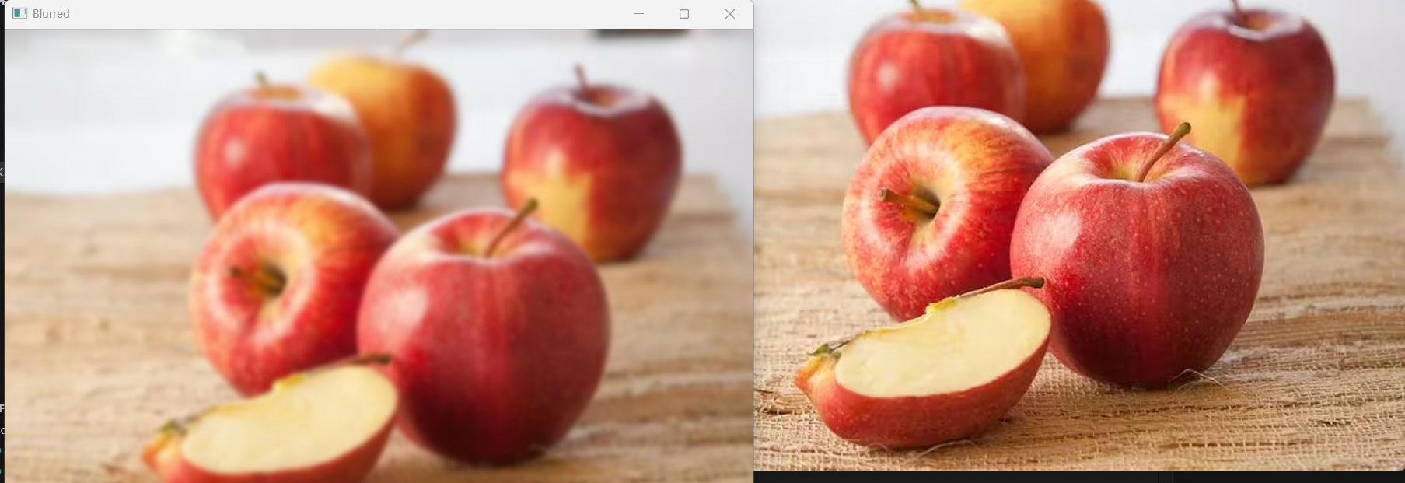  
**OBSERVATIONS:**  
1 Loads an image  
2 Applies Gaussian blur with a 15x15 kernel  
3 Shows original and blurred images  
4 Optionally saves the blurred image  
5 Waits for a key press then closes all windows

**CODE 8**

from PIL import Image

import pillow_avif # make sure pillow-avif-plugin is installed

import cv2

import numpy as np

# Load AVIF image using Pillow

pil_img = Image.open(r"C:\Users\HP-PC\OneDrive\Documents\apple.avif")

# Convert to OpenCV format

img = cv2.cvtColor(np.array(pil_img), cv2.COLOR_RGB2BGR)

# Create a blank canvas (500x500) if you want to draw shapes on top

canvas = np.zeros((500, 500, 3), dtype="uint8")

# Draw shapes on canvas

cv2.line(canvas, (0, 0), (500, 500), (255, 0, 0), 5)

cv2.rectangle(canvas, (50, 50), (200, 200), (0, 255, 0), 3)

cv2.circle(canvas, (300, 300), 80, (0, 0, 255), -1)

# Add text

cv2.putText(canvas, "OpenCV Demo", (50, 400), cv2.FONT_HERSHEY_SIMPLEX, 1, (255, 255, 255), 2)

# Show results

cv2.imshow("Original Image", img)

cv2.imshow("Shapes and Text", canvas)

cv2.waitKey(0)

cv2.destroyAllWindows()**OUTPUT:** Image with shapes and text

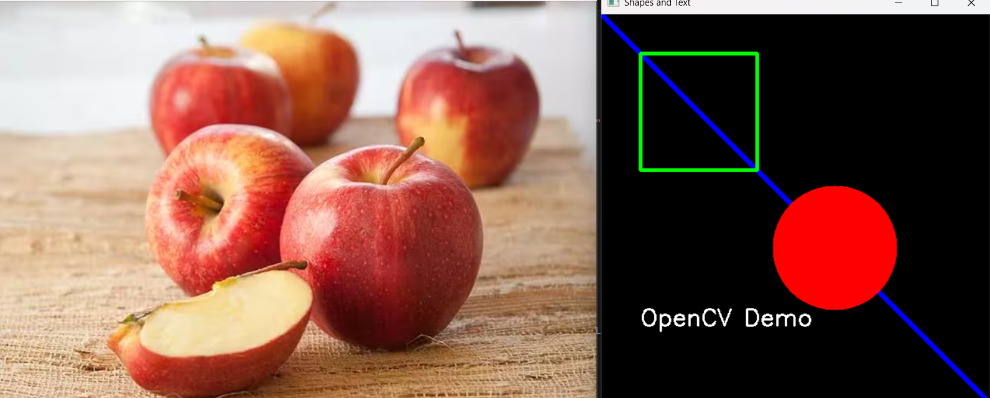  
**OBSERVATIONS:**  
1 Creates a black blank image  
2 Draws a line, rectangle, and circle  
3 Adds text on the image  
4 Displays the image  
5 Closes window after key press

**CODE 9**

from PIL import Image

import pillow_avif  # make sure pillow-avif-plugin is installed

import cv2

import numpy as np

# Load AVIF image using Pillow

pil_img = Image.open(r"C:\Users\HP-PC\OneDrive\Documents\apple.avif")

# Convert to OpenCV format

img = cv2.cvtColor(np.array(pil_img), cv2.COLOR_RGB2BGR)

# Convert to grayscale

gray = cv2.cvtColor(img, cv2.COLOR_BGR2GRAY)

# Apply binary threshold

_, thresh = cv2.threshold(gray, 127, 255, cv2.THRESH_BINARY)

# Show results

cv2.imshow("Original", gray)

cv2.imshow("Thresholded", thresh)

cv2.waitKey(0)

cv2.destroyAllWindows()

**OUTPUT:** Original and thresholded images

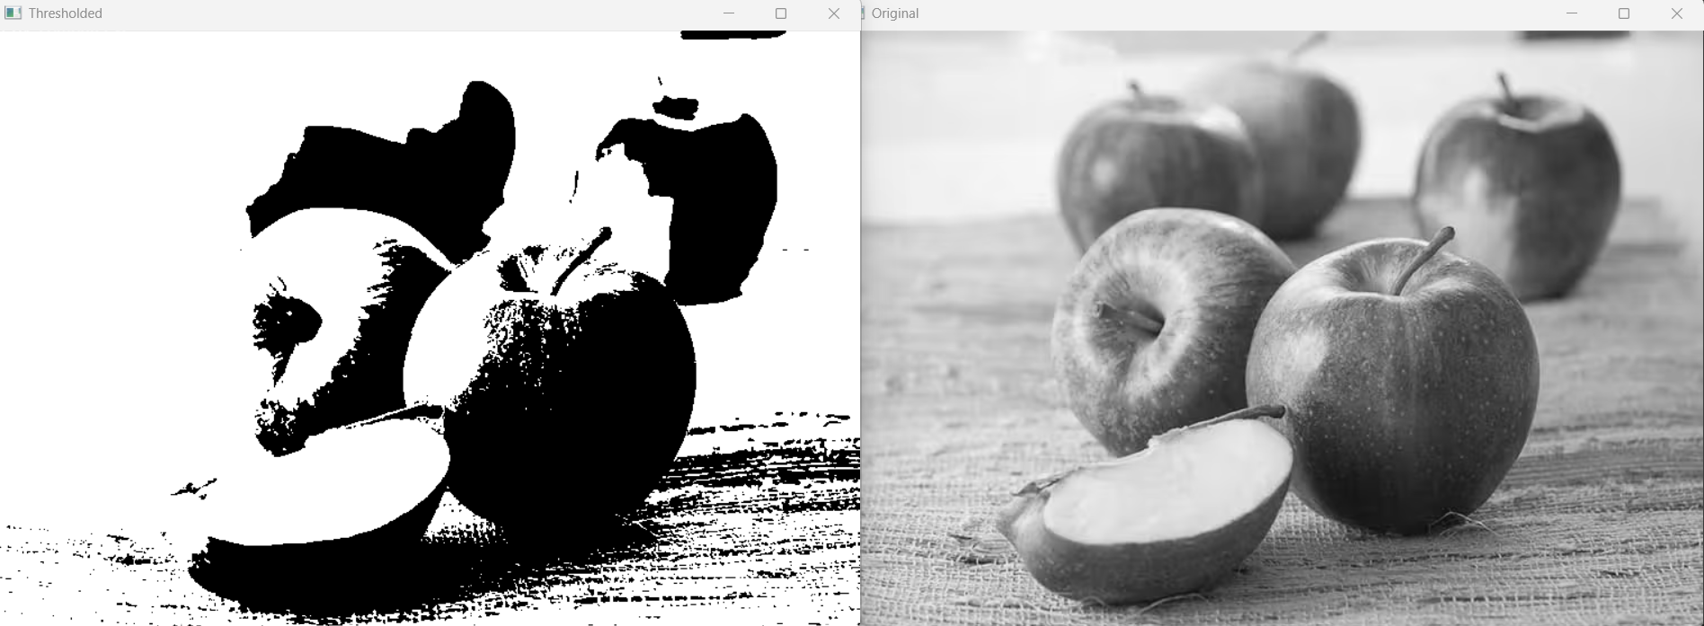  
**OBSERVATIONS:**  
1 Loads a grayscale image  
2 Applies binary thresholding to convert image into black and white  
3 Shows original and thresholded images  
4 Waits for a key press then closes all windows

**CODE 10**

from PIL import Image

import pillow_avif  # make sure pillow-avif-plugin is installed

import cv2

import numpy as np

# Load AVIF image using Pillow

pil_img = Image.open(r"C:\Users\HP-PC\OneDrive\Documents\apple.avif")

# Convert to OpenCV format

img = cv2.cvtColor(np.array(pil_img), cv2.COLOR_RGB2BGR)

# Convert to grayscale

gray = cv2.cvtColor(img, cv2.COLOR_BGR2GRAY)

# Apply Canny edge detection

edges = cv2.Canny(gray, 100, 200)

# Show results

cv2.imshow("Original Grayscale", gray)

cv2.imshow("Edges", edges)

cv2.waitKey(0)

cv2.destroyAllWindows()

**OUTPUT:** Edge-detected image

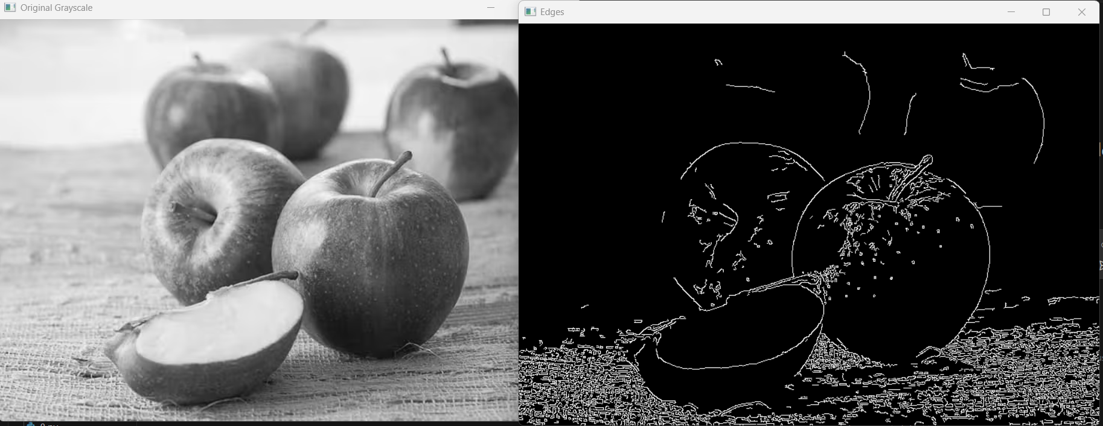  
**OBSERVATIONS:**  
1 Loads a grayscale image  
2 Detects edges using Canny edge detector  
3 Shows edges in a window  
4 Waits for a key press then closes all windows

**CODE 11**

import cv2

import matplotlib.pyplot as plt

# Load pre-trained classifier

face_cascade = cv2.CascadeClassifier(cv2.data.haarcascades + "haarcascade_frontalface_default.xml")

# Load image (use your file path)

file_path = r"C:\Users\HP-PC\OneDrive\Documents\faces.jpeg"

img = cv2.imread(file_path)

if img is None:

    print("Error: Could not read image.")

    exit()

# Convert to grayscale

gray = cv2.cvtColor(img, cv2.COLOR_BGR2GRAY)

# Detect faces

faces = face_cascade.detectMultiScale(gray, 1.1, 4)

# Draw rectangles around faces

for (x, y, w, h) in faces:

    cv2.rectangle(img, (x, y), (x + w, y + h), (255, 0, 0), 2)

# Convert BGR to RGB for Matplotlib

img_rgb = cv2.cvtColor(img, cv2.COLOR_BGR2RGB)

# Display the image

plt.imshow(img_rgb)

plt.axis('off')

plt.title("Face Detection")

plt.show()

**OUTPUT:** Image with faces detected

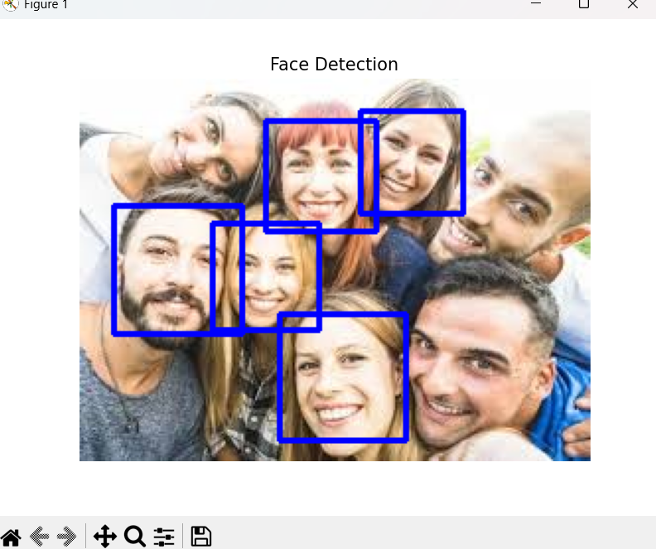  
**OBSERVATIONS:**  
1 Loads an image and Haar cascade classifier for face detection  
2 Converts image to grayscale  
3 Detects faces in the image  
4 Draws rectangles around detected faces  
5 Shows the result and closes window after key press

**CODE 12**

import cv2

import matplotlib.pyplot as plt

import os

# Load image

file_path = r"C:\Users\HP-PC\OneDrive\Documents\faces.jpeg"

if not os.path.exists(file_path):

    print("Error: File does not exist!")

    exit()

img = cv2.imread(file_path)

if img is None:

    print("Error: Could not read image.")

    exit()

# Convert to grayscale

gray = cv2.cvtColor(img, cv2.COLOR_BGR2GRAY)

# Threshold

_, thresh = cv2.threshold(gray, 127, 255, cv2.THRESH_BINARY)

# Find contours

contours, _ = cv2.findContours(thresh, cv2.RETR_TREE, cv2.CHAIN_APPROX_SIMPLE)

# Draw contours on original image

cv2.drawContours(img, contours, -1, (0, 255, 0), 2)

# Convert BGR to RGB for Matplotlib

img_rgb = cv2.cvtColor(img, cv2.COLOR_BGR2RGB)

# Display the image

plt.imshow(img_rgb)

plt.axis('off')

plt.title("Contours")

plt.show()

**OUTPUT:** Image with contours drawn

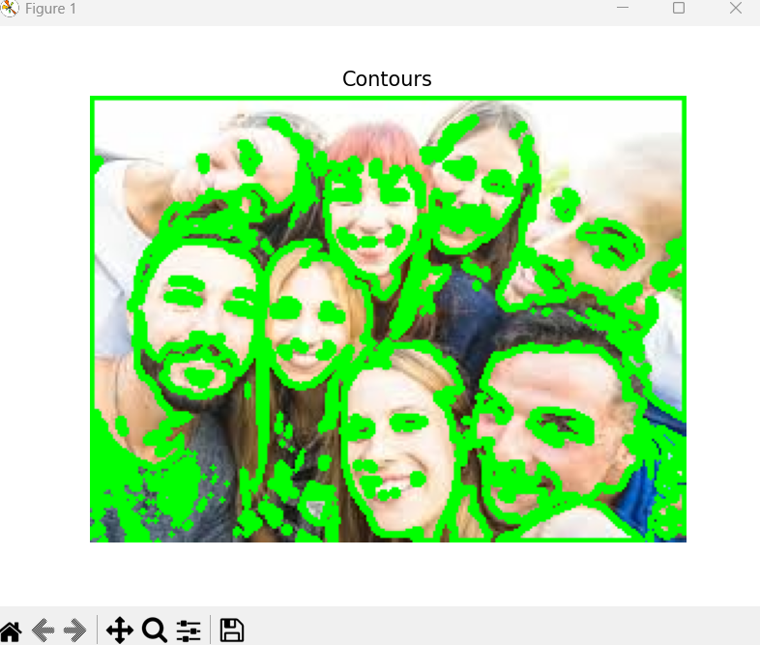  
**OBSERVATIONS:**  
1 Loads an image and converts it to grayscale  
2 Applies thresholding to get binary image  
3 Finds contours in the image  
4 Draws contours on original image  
5 Shows the result and closes window after key press

**CODE 13**

import cv2

import matplotlib.pyplot as plt

import numpy as np

import os

# Load image

file_path = r"C:\Users\HP-PC\OneDrive\Documents\faces.jpeg"

if not os.path.exists(file_path):

    print("Error: File does not exist!")

    exit()

img = cv2.imread(file_path)

if img is None:

    print("Error: Could not read image.")

    exit()

# Convert to HSV color space

hsv = cv2.cvtColor(img, cv2.COLOR_BGR2HSV)

# Define blue color range

lower_blue = (100, 150, 0)

upper_blue = (140, 255, 255)

# Create mask for blue color

mask = cv2.inRange(hsv, lower_blue, upper_blue)

# Apply mask to original image

result = cv2.bitwise_and(img, img, mask=mask)

# Convert BGR to RGB for Matplotlib

img_rgb = cv2.cvtColor(img, cv2.COLOR_BGR2RGB)

result_rgb = cv2.cvtColor(result, cv2.COLOR_BGR2RGB)

# Display images

plt.figure(figsize=(12, 6))

plt.subplot(1, 3, 1)

plt.imshow(img_rgb)

plt.title("Original")

plt.axis('off')

plt.subplot(1, 3, 2)

plt.imshow(mask, cmap='gray')

plt.title("Mask")

plt.axis('off')

plt.subplot(1, 3, 3)

plt.imshow(result_rgb)

plt.title("Filtered")

plt.axis('off')

plt.show()

**OUTPUT:** Color detection and masking

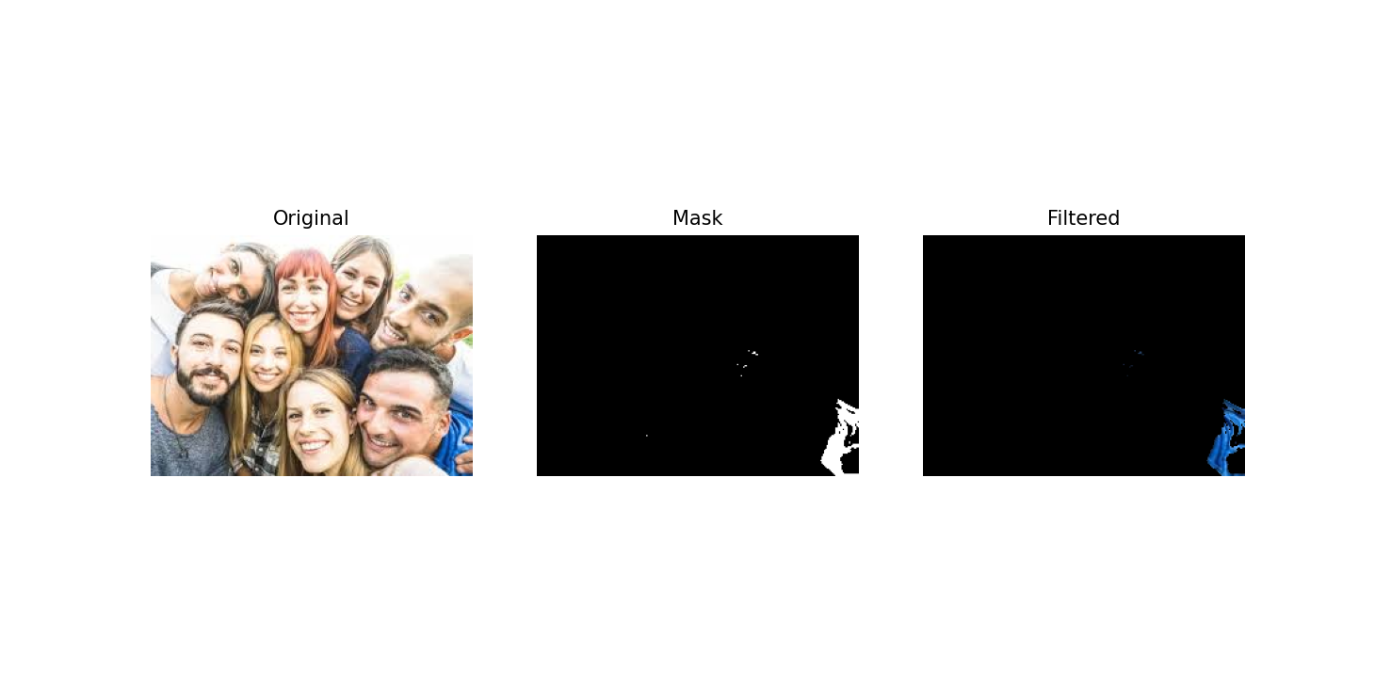  
**OBSERVATIONS:**  
1 Loads an image and converts it to HSV color space  
2 Defines blue color range  
3 Creates mask for blue color  
4 Applies mask to original image to filter blue objects  
5 Shows original, mask, and filtered images  
6 Waits for key press then closes all windows

**CODE 14**

import cv2

import numpy as np

import matplotlib.pyplot as plt

import os

# Load image

file_path = r"C:\Users\HP-PC\OneDrive\Documents\faces.jpeg"

if not os.path.exists(file_path):

    print("Error: File does not exist!")

    exit()

img = cv2.imread(file_path)

if img is None:

    print("Error: Could not read image.")

    exit()

# Initialize mask and models for grabCut

mask = np.zeros(img.shape[:2], np.uint8)

bgdModel = np.zeros((1, 65), np.float64)

fgdModel = np.zeros((1, 65), np.float64)

# Define rectangle around foreground object

rect = (50, 50, img.shape[1]-50, img.shape[0]-50)  # Adjust rectangle to image size

# Apply grabCut algorithm

cv2.grabCut(img, mask, rect, bgdModel, fgdModel, 5, cv2.GC_INIT_WITH_RECT)

# Create mask for foreground

mask2 = np.where((mask == 2) | (mask == 0), 0, 1).astype("uint8")

result = img * mask2[:, :, np.newaxis]

# Convert BGR to RGB for Matplotlib

img_rgb = cv2.cvtColor(img, cv2.COLOR_BGR2RGB)

result_rgb = cv2.cvtColor(result, cv2.COLOR_BGR2RGB)

# Display original and foreground-extracted images

plt.figure(figsize=(10, 5))

plt.subplot(1, 2, 1)

plt.imshow(img_rgb)

plt.title("Original")

plt.axis('off')

plt.subplot(1, 2, 2)

plt.imshow(result_rgb)

plt.title("Foreground Extracted")

plt.axis('off')

plt.show()

**OUTPUT:** Foreground extraction from image

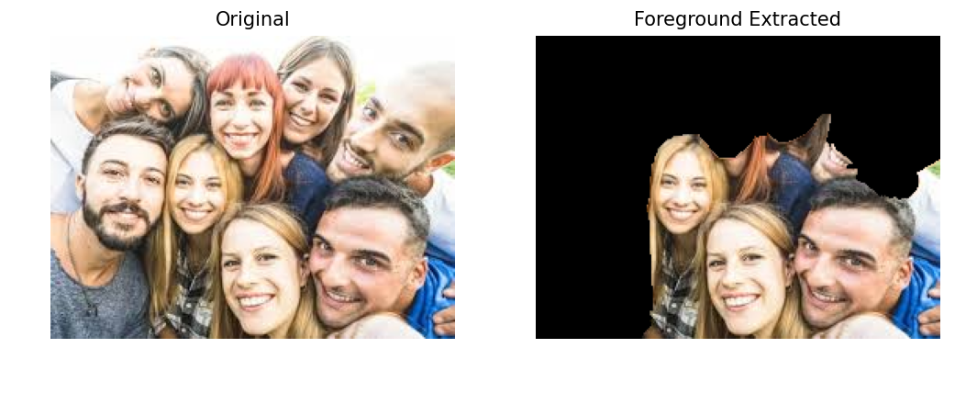  
**OBSERVATIONS:**  
1 Loads an image and creates mask for GrabCut  
2 Initializes background and foreground models  
3 Defines rectangular ROI for GrabCut  
4 Applies GrabCut algorithm to extract foreground  
5 Shows original and foreground images  
6 Waits for key press then closes all windows

**CODE 15**

import cv2

import numpy as np

# Open webcam

cap = cv2.VideoCapture(0)

if not cap.isOpened():

    print("Error: Could not open webcam.")

    exit()

while True:

    ret, frame = cap.read()

    if not ret:

        print("Failed to grab frame")

        break

    # Convert frame to HSV

    hsv = cv2.cvtColor(frame, cv2.COLOR_BGR2HSV)

    # Define blue color range

    lower_blue = (100, 150, 0)

    upper_blue = (140, 255, 255)

    # Create mask and apply it

    mask = cv2.inRange(hsv, lower_blue, upper_blue)

    result = cv2.bitwise_and(frame, frame, mask=mask)

    # Show frames

    cv2.imshow("Original Frame", frame)

    cv2.imshow("Mask", mask)

    cv2.imshow("Tracked Blue Objects", result)

    # Press 'q' to exit

    if cv2.waitKey(1) & 0xFF == ord('q'):

        break

# Release resources

cap.release()

cv2.destroyAllWindows()

**OUTPUT:** Live blue object tracking

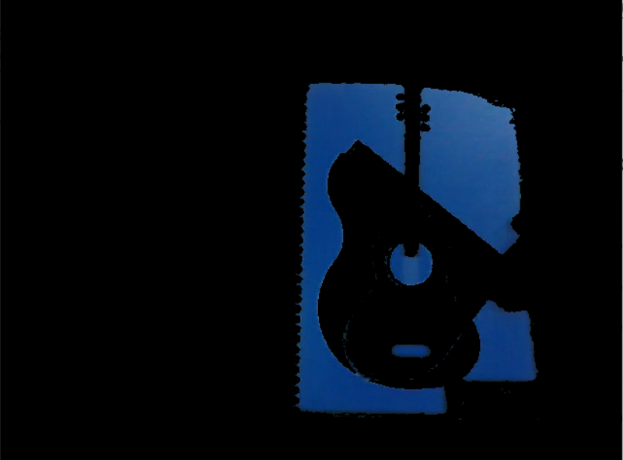  
**OBSERVATIONS:**  
1 Turns on the camera  
2 Captures frames continuously  
3 Converts frames to HSV color space  
4 Detects and masks blue objects  
5 Shows original frame, mask, and tracked output  
6 Stops when key q is pressed  
7 Releases camera and closes all windows

**CODE 16**

import cv2

import numpy as np

import matplotlib.pyplot as plt

import os

# Load image

file_path = r"C:\Users\HP-PC\OneDrive\Documents\faces.jpeg"

if not os.path.exists(file_path):

print("Error: File does not exist!")

exit()

# Read in grayscale

img = cv2.imread(file_path, 0)

if img is None:

print("Error: Could not read image.")

exit()

# Apply binary inverse threshold

_, thresh = cv2.threshold(img, 127, 255, cv2.THRESH_BINARY_INV)

# Create kernel for morphological operations

kernel = np.ones((5, 5), np.uint8)

# Apply erosion and dilation

erosion = cv2.erode(thresh, kernel, iterations=1)

dilation = cv2.dilate(thresh, kernel, iterations=1)

# Display results using Matplotlib

plt.figure(figsize=(12, 6))

plt.subplot(1, 3, 1)

plt.imshow(thresh, cmap='gray')

plt.title("Original Threshold")

plt.axis('off')

plt.subplot(1, 3, 2)

plt.imshow(erosion, cmap='gray')

plt.title("Erosion")

plt.axis('off')

plt.subplot(1, 3, 3)

plt.imshow(dilation, cmap='gray')

plt.title("Dilation")

plt.axis('off')

plt.show()

**OUTPUT:** Morphological operations on text image

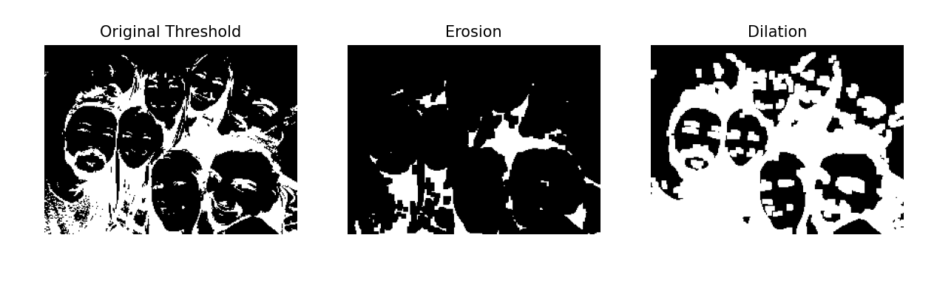  
**OBSERVATIONS:**  
1 Loads a grayscale text image  
2 Applies binary inverse thresholding  
3 Performs erosion to shrink white regions  
4 Performs dilation to enlarge white regions  
5 Shows original, erosion, and dilation results  
6 Waits for key press then closes all windows